**Project Design Phase-II**

**Data Flow Diagram & User Stories**

|  |  |
| --- | --- |
| Date | 04 November 2022 |
| Team ID | PNT2022TMID43211 |
| Project Name | Nutrition Assistant Application |
| Maximum Marks | 4 Marks |

**Data Flow Diagrams:**

A Data Flow Diagram (DFD) is a traditional visual representation of the information flows within a system. A neat and clear DFD can depict the right amount of the system requirement graphically. It shows how data enters and leaves the system, what changes the information, and where data is stored.

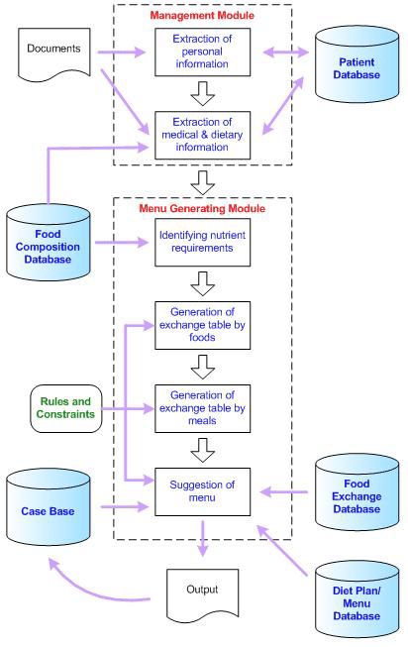

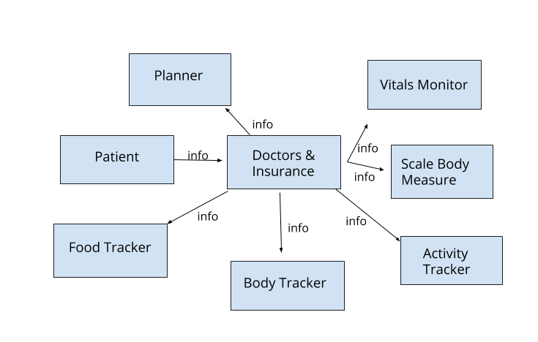

**User Stories**

| **User Type** | **Functional Requirement (Epic)** | **User Story Number** | **User Story / Task** | **Acceptance criteria** | **Priority** | **Release** |
| --- | --- | --- | --- | --- | --- | --- |
| Customer (Mobile user) | Registration | USN-1 | As a user, I can register for the application by entering my email, password, and confirming my password. | I can access my account / dashboard | High | Sprint-1 |
|  |  | USN-2 | As a user, I will receive confirmation email once I have registered for the application | I can receive confirmation email & click confirm | High | Sprint-1 |
|  |  | USN-3 | As a user, I can register for the application through Facebook | I can register & access the dashboard with Facebook Login | Low | Sprint-2 |
|  |  | USN-4 | As a user, I can register for the application through email | I can access my account / dashboard in any device | Medium | Sprint-1 |
|  | Login | USN-5 | As a user, I can log into the application by entering email & password | I can access my account / dashboard via application by entering mail id and password | High | Sprint-1 |
|  | Dashboard | USN-6 | After registration the user can find information such as food intake his/her progress in dashboard | I can see suggested food, workouts through dashboard | High | Sprint-1 |
|  | Fitness tracker | USN-7 | The periodic tracking of user health and fitness done through fitness tracker | I can see my progress periodically | High | Sprint-2 |
|  | Push notifications | USN-8 | User will get reminders ,alarms through timely notifications | I got notifications to intimate my dietary plans | Medium | Sprint-2 |
|  | Diet plans | USN-9 | User can specify their goals , preferred food items the app suggest them with a proper diet plan accordingly. | I can give my preferred food menu and customize my plan | High | Sprint-2 |
|  | Expert consultation | USN-10 | User who needs experts consultations can book their appointments and search for nearest consultant | I can consult my expert and can book appointments | Medium | Sprint-2 |
|  | Help | USN-11 | Help sections includes FAQs along with tutorial video will act as a user manual | I can ask any FAQs that I wanted to ask | Medium | Sprint-3 |
|  | Feedback | USN-12 | To receive feedback from the users to improvise the application | I can give suggestions to improvise the applications | Low | Sprint-3 |
| Customer (Web user) | Login | USN-1 | Multiple users can access the same version of the application | I can use my account through various browsers, various platforms like mobile, laptop, desktop etc. | High | Sprint-1 |
| Customer Care Executive | Help | USN-1 | Support reps interact with customers on a variety of channels such as phone, mail. | I can ask for support through app or mail | High | Sprint-3 |
|  | Troubleshoot | USN-2 | Once a support ticket is assigned ,they need to research all possible ways to troubleshoot the problem and come up with a solution. | I can report the issues that I am facing while using the application | High | Sprint-3 |
| Administrator | Management | USN-1 | Admin view and manage user permissions | I can use the application as per the given permission | High | Sprint-4 |
|  |  | USN-2 | Admin install, update, tune, diagnose and babysit both internal and third-party applications. | I will receive updates frequently | High | Sprint-4 |
|  |  | USN-3 | Admin can also add configure application, assign app to end users, create users through an app import. | I can use the assigned application version | High | Sprint-4 |